**1. Role of Intern in Organization**

An intern’s goal is to gain practical experience and learning within a specific field or industry. Their goal is to perform assigned tasks, learn about an organisation's working. Internships offer valuable opportunities for skill development, communication, & solve real world problems.

**Technical knowledge during OJT-2**

**Bootstrap**

Bootstrap was developed by Mark Otto and Jacob Thornton, both of whom were engineers at Twitter at the time. It originated as an internal tool at Twitter, where it was used to streamline and standardize the development of web applications and websites across the company. The project was initially known as "Twitter Blueprint" before being renamed Bootstrap when it was released as an open-source project to the public in August 2011. Since then, Bootstrap has evolved with contributions from the open-source community and is now maintained by a group of developers on GitHub

1. **Responsive Grid System:** Bootstrap provides a responsive grid system based on a 12-column layout. This grid system allows developers to create flexible and responsive layouts that adapt to various screen sizes, from mobile phones to desktops.
2. **Pre-styled Components**: Bootstrap includes a collection of pre-styled UI components such as buttons, forms, navigation bars, dropdowns, alerts, modals, and more. These components are designed to be visually appealing and consistent across different browsers and devices.
3. **CSS Framework:** Bootstrap is primarily a CSS framework, but it also includes optional JavaScript plugins for adding interactive functionality to your website or application. Examples of these plugins include carousels, tooltips, popovers, and modal dialogs**.**
4. **Customization:** Bootstrap can be customized using Sass variables and mixings, allowing developers to easily modify aspects such as colours, fonts, spacing, and more to match their project's design requirements.
5. **Documentation and Community:** Bootstrap has extensive documentation with examples and guidelines for using its components and features effectively. Additionally, there's a large community of developers using Bootstrap, which means plenty of resources, tutorials, and third-party plugins are available
6. **Browser Compatibility:** Bootstrap is designed to work well across different web browsers, including Chrome, Firefox, Safari, Edge, and Internet Explorer (though older versions may have limited support).
7. **Open Source and Free to Use:** Bootstrap is released under the MIT License, which means it's free to use for both personal and commercial projects. Its open-source nature encourages collaboration and contributions from the developer community.

**JavaScript**

JavaScript (JS) is a high-level, interpreted programming language primarily used for creating dynamic and interactive web content. It was created by Brendan Eich while he was working at Netscape Communications Corporation in 1995. JavaScript was initially named Mocha, then LiveScript, before settling on JavaScript. It was designed to add interactivity to web pages by allowing developers to manipulate the Document Object Model (DOM) and dynamically update the content and behaviour of web pages in response to user actions. JavaScript has since evolved into a versatile language used not only for client-side web development but also for server-side development (via platforms like Node.js), mobile app development, game development, and more. Brendan Eich's creation of JavaScript has had a profound impact on the web, shaping the way we interact with websites and web applications.

**Advantages of JavaScript:**

1. **Versatility**: JavaScript can be used for both client-side and server-side development, making it a versatile language for building a wide range of applications, from web applications to mobile apps and even desktop software.
2. **Interactivity**: JavaScript enables the creation of dynamic and interactive user experiences on the web, allowing developers to build engaging interfaces with features like animations, form validation, and real-time updates.
3. **Large Ecosystem**: JavaScript has a vast ecosystem of libraries, frameworks, and tools, such as React, Angular, Vue.js, and Express.js, which streamline development and offer solutions to common challenges.
4. **Cross-platform Compatibility**: JavaScript runs on virtually all modern web browsers, making it a cross-platform language that can reach a broad audience without requiring additional plugins or dependencies.
5. **Community Support**: JavaScript has a large and active community of developers who contribute to its development, share knowledge, provide support, and create resources such as tutorials, articles, and open-source projects.

**Data Types:**

**1. Primitive Data Types**:

* **Number**: Represents numeric values, including integers and floating-point numbers.
* **String**: Represents textual data, enclosed within single or double quotes.
* **Boolean**: Represents a logical value, either true or false.
* **Undefined**: Represents a variable that has been declared but not assigned a value.
* **Null**: Represents the intentional absence of any value.
* **Symbol**: (Introduced in ES6) Represents a unique identifier.

1. **Reference Data Types**:

* **Object**: Represents a collection of key-value pairs, where keys are strings and values can be any data type, including other objects.
* **Array**: Represents an ordered collection of elements, with each element accessible by an index.
* **Function**: Represents a reusable block of code that can be invoked with arguments.

### Operators:

JavaScript supports various types of operators for performing different operations:

1. **Arithmetic Operators**: Used for performing arithmetic operations such as addition (+), subtraction (-), multiplication (*), division (/), and modulus (%).
2. **Assignment Operators**: Used for assigning values to variables and modifying their values, such as =, +=, -=, *=, /=, etc.
3. **Comparison Operators**: Used for comparing values and returning true or false, such as ==, ===,!=, !==, >, <, >=, <=.
4. **Logical Operators**: Used for combining or negating logical expressions, such as && (logical AND), || (logical OR), ! (logical NOT).
5. **Unary Operators**: Operators that work on a single operand, such as ++ (increment), -- (decrement), typeof, delete, etc.
6. **Ternary Operator (Conditional Operator)**: A conditional operator (?, :) used for making decisions based on a condition.

**2.Use Case**

**Use case for Bootstrap**

Creating a website with a navbar along with brand logo, using grid systems and container systems in bootstrap to get this following result added images with a tag and uses margin and padding properties, used text formatting to align texts.

HTML:

<!DOCTYPE html>

<html lang="en">

<head>

    <meta charset="UTF-8">

    <meta name="viewport" content="width=device-width, initial-scale=1.0">

    <title>Document</title>

    <link rel="stylesheet" href="bootstrap.css">

    <link rel="stylesheet" href="animate.css">

</head>

<body class="bg-light container-fluid">

    <div class="nav-bar ">

        <nav class="navbar navbar-expand-sm bg-light navbar-light">

            <div class="container-fluid ">

                <a class="navbar-brand" href="index.html">

                    <img src="img/rr logo.png" style="width:40px;" class="rounded-pill">

                </a>

                <ul class="navbar-nav navbar-collapse">

                    <li class="nav-item text-left">

                        <a class="nav-link text-center" href="#">Ghost</a>

                    </li>

                    <li class="nav-item">

                        <a class="nav-link text-dark " href="#">Wraith</a>

                    </li>

                    <li class="nav-item">

                        <a class="nav-link text-dark" href="#">Cullinan</a>

                    </li>

                </ul>

            </div>

        </nav>

    </div>

    <div class="container-fluid bg-dark text-light text-center p-5">

        <p class="h1  " id="heading">Rolls Royce</p>

        <p class="h4">"Strive for perfection in everything you do"</p>

    </div>

    <div class="container-fluid text-left m-1">

        <div class="row">

            <div class="col-md-3 bg-light text-dark border">

                <div class=" h2 " id="p">About:</div>

                <div class=" h3">Image of Rolls Royce</div>

                <div><img src="img/rr1 img.jfif" class="" alt=""></div>

                <p class="ml-1 mt-2 p-1">Lorem ipsum dolor sit amet consectetur adipisicing elit. Tempora maxime in,

                    dolor

                    cumque soluta

                    possimus eligendi iusto omnis voluptatibus pariatur. Magnam sint fugit fuga qui corporis laborum

                    necessitatibus inventore ullam?

                </p>

            </div>

            <div class="col-md-9 bg-light text-dark border">

                <div class="h2 ">About:</div>

                <div class="h3">

                    <p>Feb 20,2024</p>

                </div>

                <div><img src="img/rr2 img.jfif" class="" alt=""></div>

                <p class="ml-1 mt-2 p-1">Lorem ipsum dolor sit amet consectetur adipisicing elit. Tempora maxime in,

                    dolor

                    cumque soluta

                    possimus eligendi iusto omnis voluptatibus pariatur. Magnam sint fugit fuga qui corporis laborum

                    necessitatibus inventore ullam? Lorem ipsum dolor sit, amet consectetur adipisicing elit. Sint hic

                    laborum necessitatibus consectetur aut ab officiis nihil ex vero corporis dolorum quos error fugiat

                    culpa sunt optio eaque, laboriosam aliquam.

                </p>

                <p></p>

            </div>

        </div>

    </div>

    <div class=" container-fluid row ml-1 mt-2">

        <nav class="navbar bg-light col-md-3 text-center">

            <div class="container-fluid">

                <ul class="navbar-nav col  h5">

                    <li class="nav-item">

                        <a href="#" class="nav-link text-primary ">Blog</a>

                    </li>

                    <li class="nav-item">

                        <a href="#" class="nav-link text-primary ">News</a>

                    </li>

                    <li class="nav-item">

                        <a href="#" class="nav-link text-primary ">About</a>

                    </li>

                    <li class="nav-item">

                        <a href="#" class="nav-link text-primary ">Contact</a>

                    </li>

                </ul>

            </div>

        </nav>

        <div class="col-md-9 border">

            <p class="h2 text-left ">

                Introducing:Rolls Royce Boat Tail</p>

            <p class="h3">Feb 20,2024</p>

            <img src="https://w0.peakpx.com/wallpaper/191/143/HD-wallpaper-rolls-royce-boat-tail-2021.jpg" alt="rel img"

                height="250px" width="400">

            <p class="m-1 p-1 ">

                Lorem ipsum dolor sit amet consectetur adipisicing elit. Corporis, reiciendis quas

                eveniet quaerat

                reprehenderit quam autem eos facilis, assumenda quod libero praesentium labore molestias illo vero quasi

                nihil rerum. Cumque.

            </p>

        </div>

    </div>

    <div class="bg-dark container-fluid p-5 text-light text-center">Footer</div>

</body>

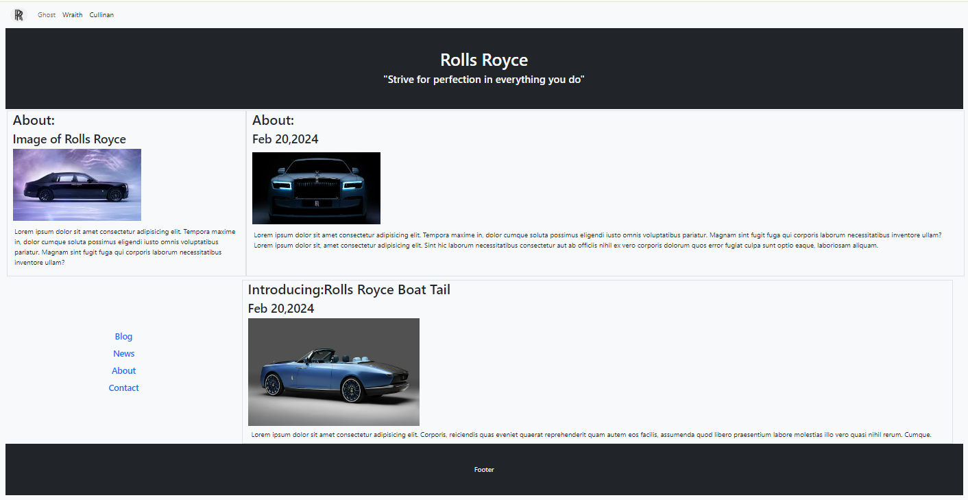</html>

**Use case for JavaScript**

**Usecase-1**

**HTML and JS:**

<!DOCTYPE html>

<html lang="en">

<head>

    <meta charset="UTF-8">

    <meta name="viewport" content="width=device-width, initial-scale=1.0">

    <title>Document</title>

    <link rel="stylesheet" href="../css/bootstrap.css">

</head>

<body>

    <div class="container p-5  ">

        <p class="h2 text-left">Login</p>

        <span style="color: rgb(255, 0, 0);font-size: 20px;" id="msg"></span> <br>

        <label class=>Name:</label> <br>

        <input type="text" id="name" class="form-control  mb-3 rounded-3 " onchange="validate()"><br>

        <label>contact:</label>

        <input type="email" id="contact" class="form-control  mb-3 rounded-3" onchange="validate()"><br>

        <input type="submit" id="submit" class="btn btn-primary text-white  btn-outline-success   d-block  mt-3">

        <script>

            function validate() {

                let name = document.getElementById("name").value;

                let contact = document.getElementById("contact").value;

                if (name.length < 3 || name == "" || typeof (name) == Number) {

                    document.getElementById("msg").innerHTML = "Please enter valid name"

                }

                else if (contact.length < 10 || contact.length > 10) {

                    document.getElementById("msg").innerHTML = "Enter valid contact number";

                }

                else {

                    document.getElementById("msg").innerHTML = "";

                }

            }

        </script>

    </div>

</body>

</html>

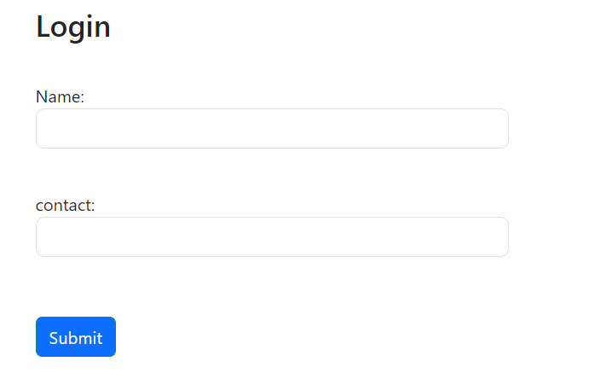

**Use case-2**

<!DOCTYPE html>

<html lang="en">

<head>

    <meta charset="UTF-8">

    <meta name="viewport" content="width=device-width, initial-scale=1.0">

    <title>Document</title>

    <link rel="stylesheet" href="../css/bootstrap.css">

</head>

<body class=" container-fluid bg-info m-5">

    <div class="input ">

        <h1>Password generator</h1> <br>

        <input type="number" id="num" min="1" style="height: 35px;">

        <button type="submit" class="btn mt-2 btn-primary btn-outline-success text-light"

            onclick="generatePassword()">Click to generate</button>

    </div>

    <div class="row">

        <div class="card col mt-3 ml-3">

            <div class="card-body">

                <h4 id="pass"></h4>

            </div>

        </div>

    </div>

    <script>

        function generatePassword() {

            let num = document.getElementById("num").value;

            if (num > 8 && num <= 25) {

                let pass = '';

                let str = 'ABCDEFGHIJKLMNOPQRSTUVWXYZ' +

                    'abcdefghijklmnopqrstuvwxyz0123456789@#$';

                for (let i = 0; i < num; i++) {

                    let char = Math.floor(Math.random() * str.length);

                    pass += str.charAt(char);

                    let res = document.getElementById("pass");

                    res.innerHTML = `Your newly generated password of length ${num} is: ${pass}`;

                }

            }

            else {

                pass.innerHTML = "can only generate between 8 and 25 characters"

            }

        }

    </script>

</body>

</html>

